打印时间：20XX年X月X日
 | 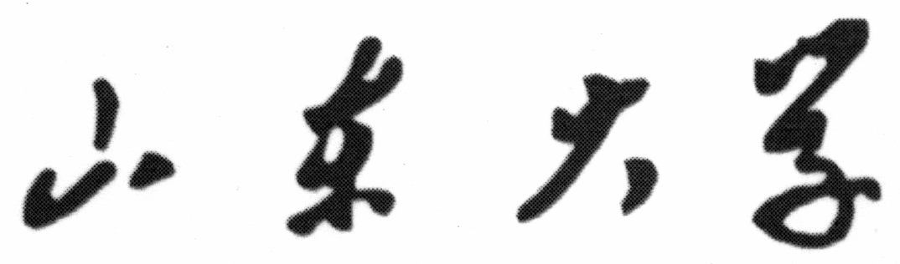  SHANDONG UNIVERSITY
▃▃▃▃▃▃▃▃▃▃▃▃▃▃▃▃▃▃▃▃▃▃▃▃▃▃▃▃▃▃▃▃▃▃▃▃▃▃▃▃▃▃▃▃▃▃▃▃▃▃▃▃▃▃▃▃▃▃▃▃▃▃▃▃▃▃▃▃▃▃▃▃▃▃▃▃▃▃▃▃▃▃▃▃▃▃▃▃▃▃▃▃▃▃▃▃
School Report of Graduate Students
Student Number |  | Department
Name |  | Specialty
Type of Program |  | Period of Study | From To Advisor

Course Title |  | Course Item | Credits | Total Class Hours | Marks | Date of Exam
Credits for R |  | (Signature)  Dean of Academic Affairs
Credits for F
Remarks
Courses Items: R (Required Courses), F (Free Elective Courses).
Marks: There are two marking systems in Required Courses: 1.scores are represent in X%; 2. D=Pass, F=Failure

