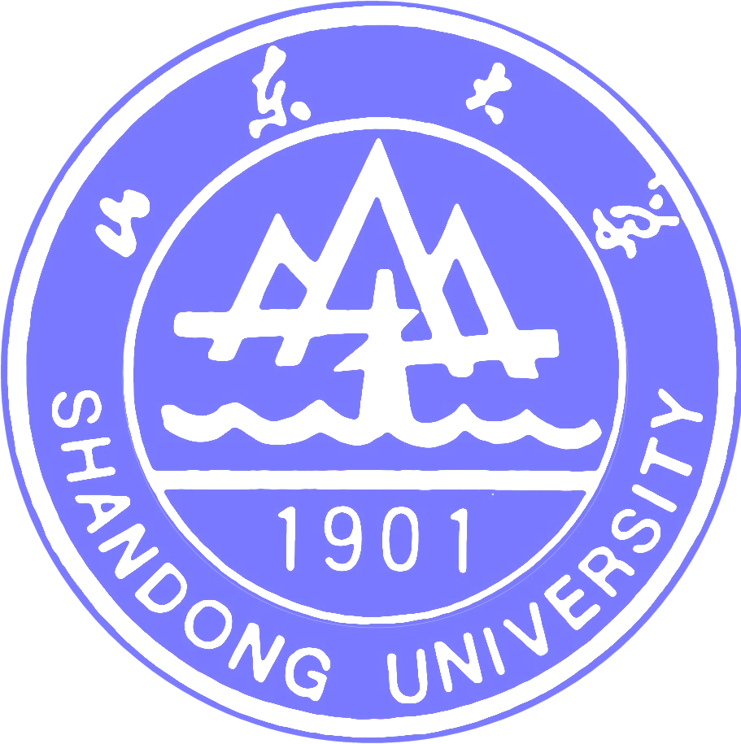

研究生院
GRADUATE SCHOOL OF SHANDONG UNIVERSITY
27 Shanda Nanlu, Jinan , TEL:+86-(0)531-88364673
Shandong , P.R.China 250100 FAX:+86-(0)531-88563495 E-mail:pyk@sdu.edu.cn

证 明(样表)
刘洁，女，1979年2月22日出生，学号200520052。自2005年9月起至今在山东大学生命科学学院水生生物学专业攻读理学博士学位。现已获得国家留学基金资助，作为博士生（联合培养博士生）到美国进行12个月的科研学习工作,其回国后将继续在山东大学的学业。学校同意派出。
特此证明。
学院审核人签字： 山东大学研究生院
学院公章 二○○七年六月十五日

CERTIFICATION
This is to certify that Ms. Liu jie，born on February 22,1979, Student ID.200520052, has been studying the graduate program for Doctor’s Degree on Aquatic Biology in the School of Life Science, Shandong University from Sept. 2005 to now.
Now she has been awarded a scholarship under the State Scholarship Fund to pursue her study in the United States of America as a PhD candidate（ joint PhD candidate ）for a period of 12 months. After she come back, she will continue her study in Shandong University. So she is permitted to go abroad by Shandong University.

Graduate School
Shandong University
Jinan, P.R. China
Jun.15，2007

